Astro Phys4080 Project 4
Q1:
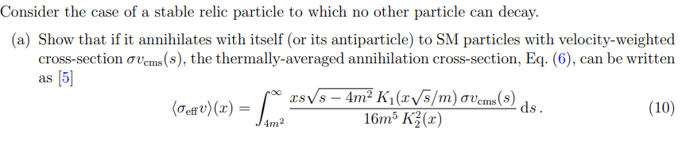
All required equations,
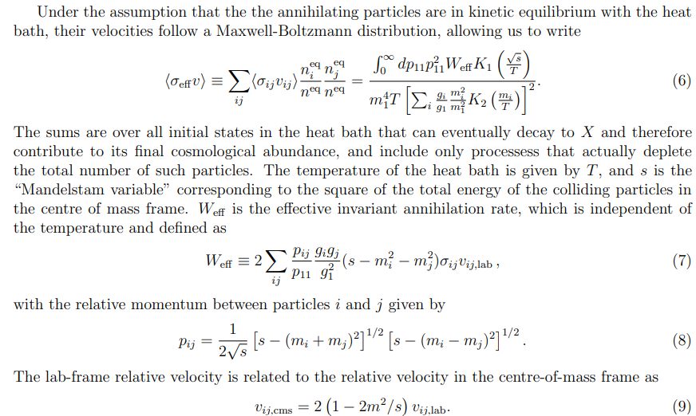
Thus, since we consider a stable relic that can only interact with itself or its antiparticles that means
$$p_{ij}=p_{11} \\ p_{11}=\frac{1}{2\sqrt{s}}{\left[s-{\left(m+m\right)}^{2}\right]}^{\frac{1}{2}}{\left[1-{\left(m-m\right)}^{2}\right]}^{\frac{1}{2}} \\ =\frac{1}{2\sqrt{s}}{\left[s-4m^{2}\right]}^{\frac{1}{2}}{\left[s\right]}^{\frac{1}{2}} \\ =\frac{\sqrt{s}\sqrt{s-4m^{2}}}{2\sqrt{s}} \\ =\frac{\sqrt{s-4m^{2}}}{2}$$
As such the derivative with respect to s is then,
$$\frac{dp_{11}}{ds}=\frac{1}{4\sqrt{s-4m^{2}}}→dp_{11}=\frac{ds}{4\sqrt{s-4m^{2}}}.$$
So, if we have $p_{11}=0$, then we have $s=4m^{2}$, if $p_{11}=∞$, then $s=∞$ as such we can then switch the bounds of the integral from
$$\int_{0}^{∞}{dp_{11}}→\int_{4m^{2}}^{∞}{\frac{1}{4\sqrt{s-4m^{2}}} ds.}$$
Also, we see that
$$p_{11}^{2}=\frac{s-4m^{2}}{4}.$$
As such we have simplified equation (6) down to the form
$$\left\langle σ_{eff}v\right\rangle =\frac{\int_{4m^{2}}^{∞}{ds\frac{s-4m^{2}}{4}}\frac{1}{\sqrt{s-4m^{2}}}ω_{eff}k_{1}\left(\frac{\sqrt{s}}{T}\right)}{m^{4}T{\left[k_{2}\left(\frac{m}{T}\right)\right]}^{2}}.$$
We then see that for self-interacting case,
$$v_{ij,lab}=\frac{v_{ij,cms}}{2\left(1-\frac{2m^{2}}{s}\right)}$$
So,
$$ω_{eff}=\frac{2\left(s-2m^{2}\right)}{2\left(1-\frac{2m^{2}}{s}\right)}v_{ij,cms} \\ ω_{eff}=sσv_{cms}$$
And if we then set $T=\frac{m}{x}$ and substitute all changes into equation (6) we get
$$\left\langle σ_{eff}v\right\rangle =\int_{4m^{2}}^{∞}{ds}\frac{xs\sqrt{s-4m^{2}}∙σv_{cms}{\left(s\right)∙k}_{1}\left(\frac{x\sqrt{s}}{m}\right)}{{16m}^{5}k_{2}^{2}\left(x\right)}$$
Q2:
The code used to produce the present-day cosmological density ΩDMh 2 of a thermal relic dark matter candidate of mass m. as well as all the required outputs for questions 3 and 4.
Code bellow in appendix:
Q3:
- The dimensionless comoving abundance Y as a function of x (i.e. plot the dark matter abundance as the Universe cools), for a few indicative values of m_χ and ⟨σv⟩
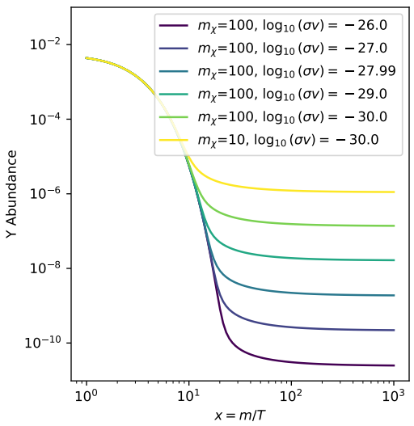
Here we see that the Y abundance depends on both mass and interaction cross section, we also notice that up to around x=10 for each different interaction cross section all lines are equivalent. Then they separate where the lower the order of $\log_{10}{(σv)}$ the bigger the Y abundance. Also, we not that for the same interaction cross section, the smaller mass (10 times smaller) results in a 10 times smaller y abundance from x=10 onwards. Also, we note that we use 27.99 instead of 28, that is due to the discontinuity that occurs at 28 which results in the plot being ruined as such we move as close to 28 as possible and 27.99 is the best value we can use.
- The present-day abundance Ωχh 2 as a function of mχ (in GeV) for a few values of ⟨σv⟩.
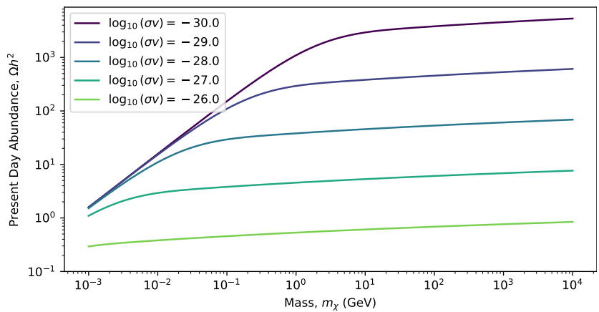
We see that for all separate interaction cross sections that as mass increases so too does the present-day abundance. We note that there is initially a steep almost linear increase initially for all interaction cross sections, but later we observe a much less steep again almost linear increase in abundance. We expected this to be linear since abundance is linearly proportional to mass. We note that the bend in the plot between the varying steepness linear parts is most like due to the freezing out of particles of different species.
- The band in the mχ, ⟨σv⟩ plane for which the relic density of your WIMP matches the dark matter abundance observed in the latest Planck analysis of the CMB, to within the 3σ confidence level. Also indicate on your plot the region of parameter space where your WIMP produces only a fraction of the observed dark matter, and is therefore still viable, but somewhat less appealing as a theory than where it explains all of dark matter.
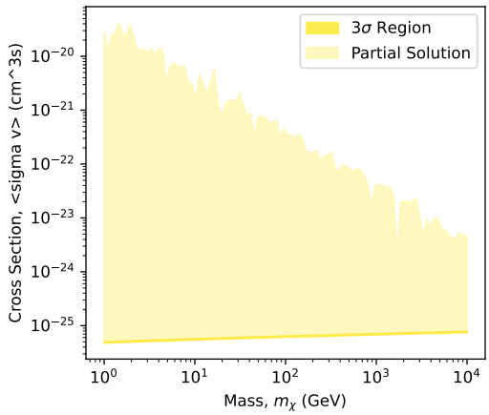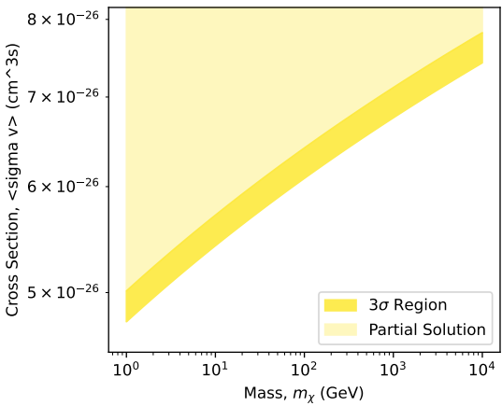
We see that as mass increases so too does the cross-section of the WIMP. We see in the right plot with the 3 sigma region that all the dark matter can be explained.

4a) The thermally-averaged cross-section (Eq. (10)) as a function of mS, for x = 10, 20, 50 and 100. Plot the curves for all four x values on the same axes, and assume λhS = 10−3.
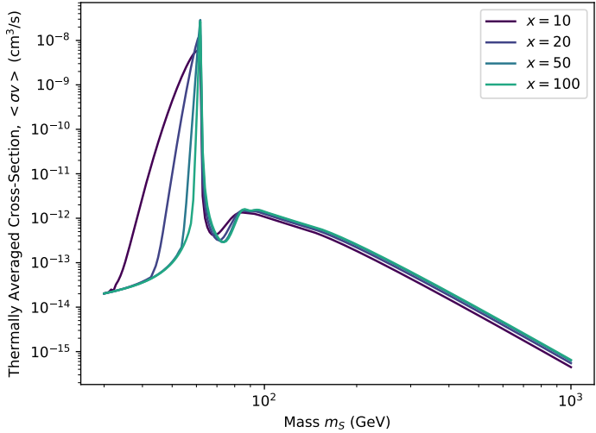
We see a large peak appear around a mass of 60Gev for each x value noting that the peaks are sharper for larger x and broader for smaller x. we then observe a small dip almost quadratic after this peak up until around the vacuum expectation value of $v_{0}=246GeV$. Where the plot is almost linearly decreasing as mass grows.
4b) The dimensionless comoving abundance Y as a function of x, for a few indicative values of mS and λhS.
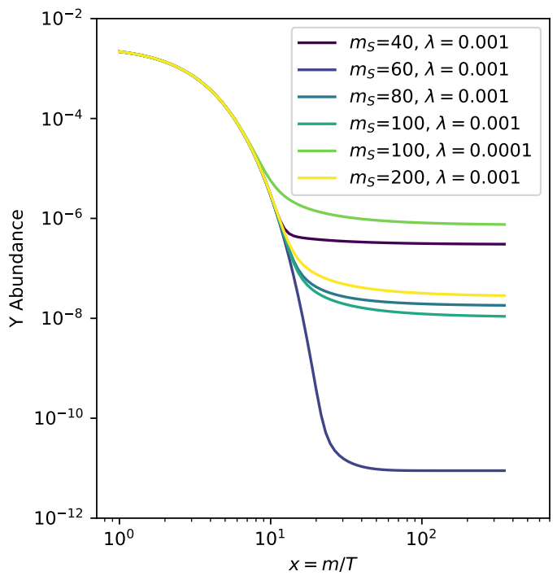

4c) The present-day abundance ΩSh 2 as a function of mS, for λhS = 10−3 and 50 GeV < mS < 200 GeV. Indicate the central observed value of Ωχh 2 with a dashed line.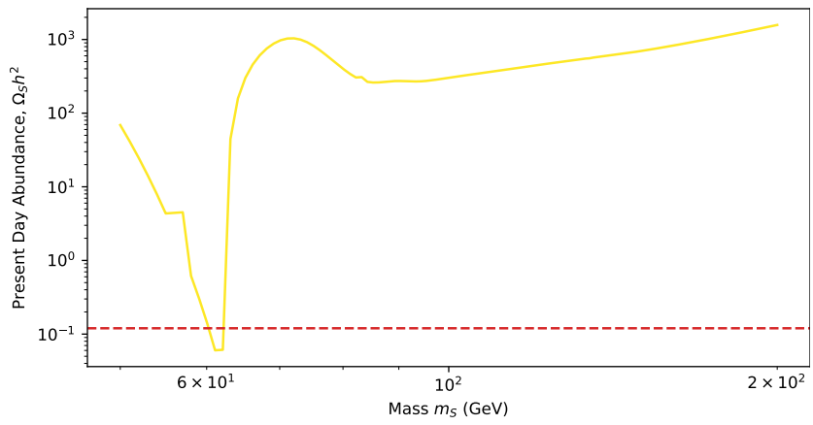
Spline plot.
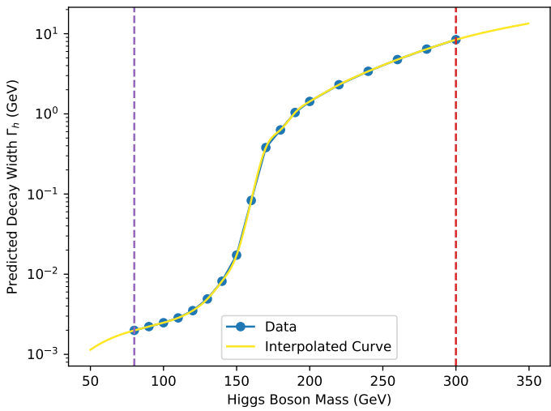
Appendix(code):
#constants
h_eff = 86.25 #effective entropic degree of freedom
g_st = 86.25**(1/2) #effective energetic degree of freedom
m_pl = 1.2 * 1e19 #planck mass, GeV
m_h = 125 #higgs mass, GeV
mu = np.sqrt(np.pi / 45) * m_pl * g_st**(1/2) #scaling constant
v0 = 246 #vacuum expectation value, GeV

#Q (GeV)
Q = np.array([80.0, 90.0, 100.0, 110.0, 120.0, 130.0, 140.0, 150.0, 160.0, 170.0, 180.0, 190.0, 200.0, 220.0, 240.0, 260.0, 280.0, 300.0])
#Gamma/width (MeV)
Gamma_h = np.array([1.99, 2.22, 2.48, 2.85, 3.51, 4.91, 8.17, 17.3, 83.1, 380, 631, 1040, 1430, 2310, 3400, 4760, 6430, 8430]) / 1000
#in GeV
spline_Gamma_h = interp.CubicSpline(Q, np.log10(Gamma_h), extrapolate=True)
def convert(ov):
#Converts from units of cm^3/s to GeV
return ov / (1.17 * 1e-17)

def gamma_h(m):
#Returns interpolated/extrapolated predictions for the higgs boson decay at a given mass

if m > 300:
return Gamma_h[-1] + 0.1 * (m - 300)
return 10**spline_Gamma_h(m)

def integrand_sv_eff_t(t, x, m, lambda_h):
# x is Effective temperature of the universe (x = particle mass / temperature)
# m is Mass of the particle
# lambda_h is Dimensionless coupling that describes the interaction strength between DM and higgs boson.
# Get out sv_eff which is the integrand at a specific value of x

s = 1 / t
sqrts = np.sqrt(s) #define for simplicity
Dhs = 1 / ((s - m_h**2)**2 + m_h**2 * gamma_h(m_h)**2)
ovcms = 2 * (lambda_h * v0)**2 / sqrts * Dhs * gamma_h(sqrts)
sv_eff = x * s * np.sqrt(s - 4 * m**2) * sp.kn(1, x * sqrts / m) * ovcms / (16 * m**5 * sp.kn(2, x)**2 * t**2) #integrand in eq 10.
return sv_eff

def O_effV(x, m, lambda_h):
# x is Effective temperature of the universe (x = particle mass / temperature)
# m is Mass of the particle
# lambda_h is Dimensionless coupling that describes the interaction strength between DM and higgs boson.
# Get out integral which is the the effective thermally averaged cross section for the particle at the universe epoch defined from x

smin = 4.0 * pow(m, 2)
smax = 20.0 * pow(m, 2)
integral, err = integ.quad(integrand_sv_eff_t, 1.0/smax, 1.0/smin, args=(x, m, lambda_h), epsabs=0, epsrel=1.0e-3) #integrate
return integral

def Y_eq(x, spin):
# get out the equilibrium abundance of a particle given by Maxwell-Boltzmann approximation
# where x is effective temperature of the universe (x = particle mass / temperature)
# and spin is Particle spin

return (45 / (4 * np.pi**4)) * (x**2 / h_eff) * (2 * spin + 1) * sp.kn(2, x)

